Project Design Phase-II
Technology Stack (Architecture & Stack)

Date | 25 February 2026
Team ID | LTVIP2026TMIDS78743
Project Name | Educational Organisation Using ServiceNow
Maximum Marks | 4 Marks

Technical Architecture:
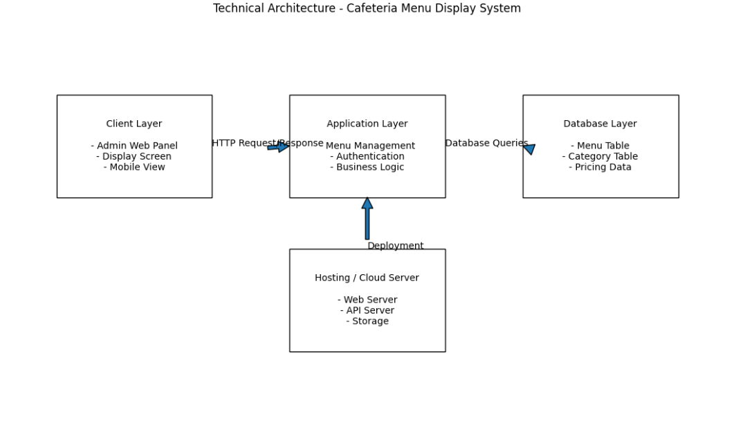

Table-1 : Components & Technologies:
S.No | Component | Description | Technology
1 | User Interface | How cafeteria staff and customers interact with the system. | HTML, CSS, JavaScript
2 | Application Logic-1 | Automated fetching and rendering of menu items on display. | JavaScript Fetch API
3 | Application Logic-2 | Admin authentication and menu management operations. | Python Flask(Backend)
4 | Application Logic-3 | Auto-refresh functionality every 5 minutes. | JavaScript setInterval
5 | Database | Core tables for storing users, categories, and menu items. | MySQL Relational Database
6 | Local Server | Centralized hosting of application and database. | Localhost / Flask Development Serve
7 | Infrastructure | Application development and deployment environment. | VS Code, XAMPP, Git

Table-2: Application Characteristics:
S.No | Characteristics | Description | Technology
1 | Open-Source Frameworks | Scripting and UI frameworks utilized by the platform. | Flask, Bootstrap, jQuery
2 | Security Implementations | Access controls for admin panel and sensitive menu data. | Session Management, Password Protection
3 | Scalable Architecture | 3-tier architecture separating UI, Logic, and Data layers. | Frontend (HTML/CSS/JS) + Backend (Flask) + Database (MySQL)
4 | Availability | Accessibility of the cafeteria menu system. | Local Network / Localhost
5 | Performance | Efficiency of real-time menu updates and auto-refresh. | Asynchronous JavaScript, Optimized Database Queries

